**NAME: Aftab Hussain**

**Roll No: 06**

**PRN: 240850320006**

1. Write a program to check whether a number is prime or not.

OUTPUT:  
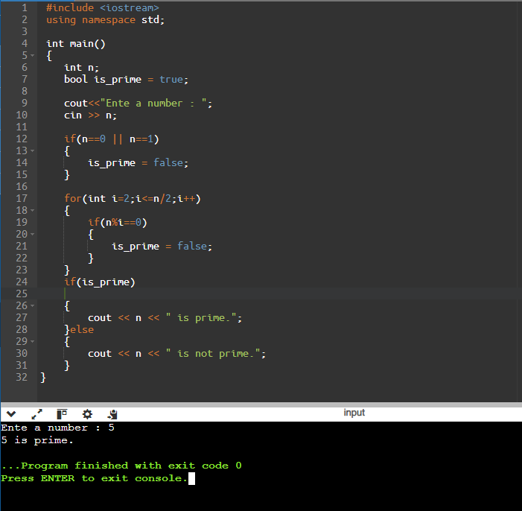

2. Write a program to generate first N prime numbers. Accept N from user.

OUTPUT:

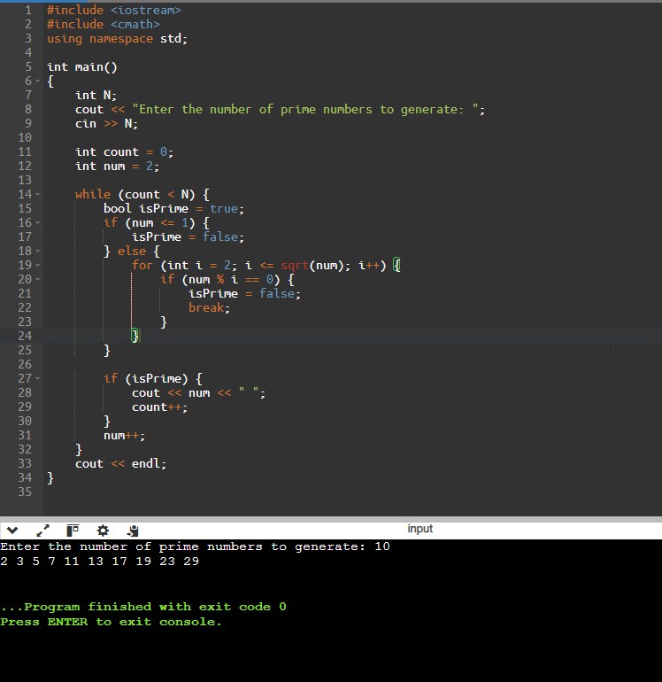

3. Write a program to generate following pyramid

A

AB

ABC

..... A..............Z

OUTPUT:

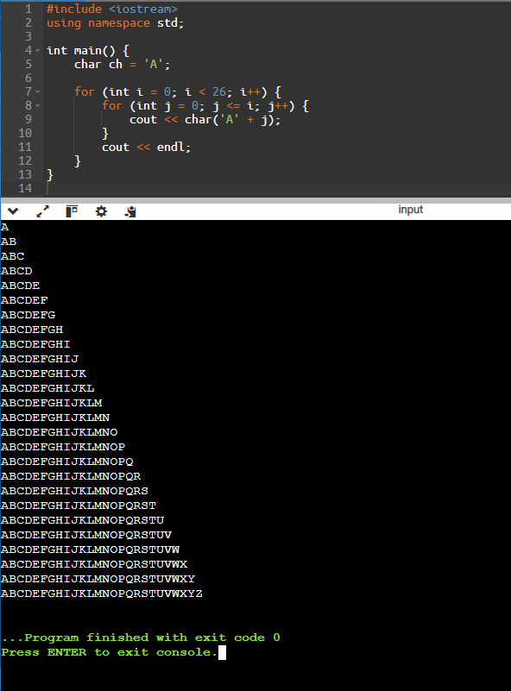

4. Write a menu driven program to perform mathematical operations on two numbers.

1. Add

2. Sub

3. Mul

4. Div

5. Exit

accept the menu option and numbers form user.

OUTPUT:

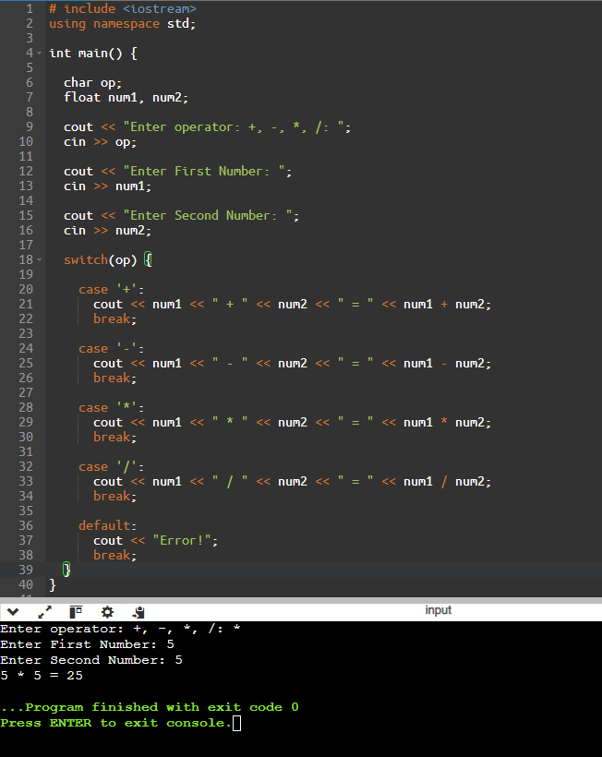

5. Generate following pyramid, accept the level from the user as input

1

1 2

1 2 3

..... 1................N

where N is the level accepted as input.

OUTPUT:

